

LAB REPORT

**CSE2004 – DATABASE MANAGEMENT SYSTEMS**



**(B.Tech. COMPUTER SCIENCE AND ENGINEERING)**

**FALL SEMESTER 2021-22**

|  |  |
| --- | --- |
| **Name:** | PRASOON SONI |
| **Reg. No:** | 20BCE2960 |
| **Slot:** | L57+L58 |
| **Faculty Name:** | **ANBARASI M MA’AM** |

**VIT – A Place to Learn; A Chance to Grow**

**ASSIGNMENT – 2**

**OPERATORS AND FUNCTONS**

**QUESTION – 1**

Find the male employee names having salary greater than 75000$.

**QUERY**

SELECT

    first_name,

    mid_name,

    last_name

FROM

    employee

WHERE

    sex IN ('m', 'M')

    AND salary > 75000;

**RESULT**

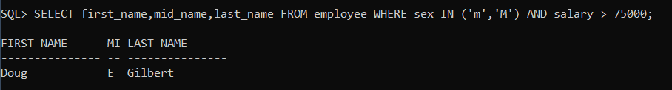

**QUESTION – 2**

Find the employee names whose salary falls in the range of 50000 and 80000.**QUERY**

SELECT

    first_name,

    mid_name,

    last_name

FROM

    employee

WHERE

    salary BETWEEN 50000

    AND 80000;

**RESULT**

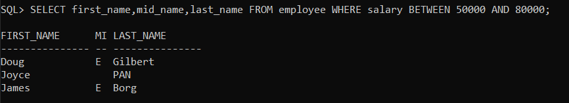

**QUESTION – 3**

Find all the employees who have no supervisor.

**QUERY**

SELECT

    *

FROM

    employee

WHERE

    supervisor_ssn IS NULL;

**RESULT**

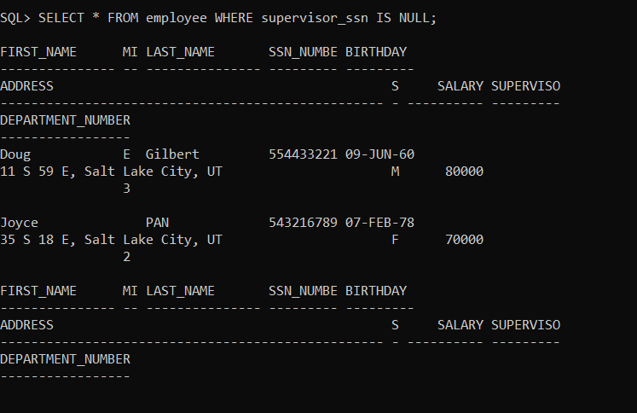

**QUESTION – 4**

Get the employee names whose bdate not later than 1998.

**QUERY**

SELECT

    first_name || mid_name || last_name as "name"

FROM

    employee

WHERE

    birthday <('01-JAN-1998');

**RESULT**

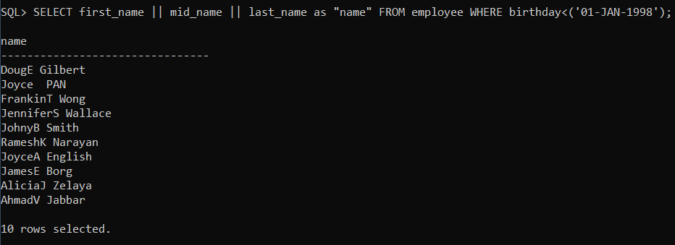

**QUESTION – 5**

Retrieve the employee names whose first name start with ‘L’ and have 5 characters

in total.

**QUERY**

SELECT

    first_name,

    mid_name,

    last_name

FROM

    employee

WHERE

    first_name LIKE 'L%'

    AND length(first_name) = 5;

**RESULT**



**QUESTION – 6**

Find the employee details whose middle initial is null.

**QUERY**

SELECT

    *

FROM

    employee

WHERE

    mid_name IS NULL;

**RESULT**

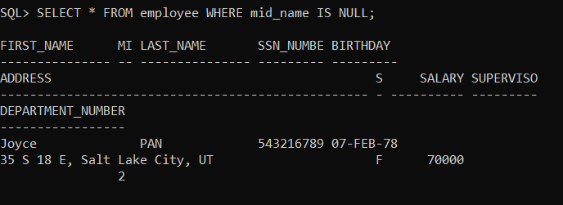

**QUESTION – 7**

Display the department names that ends with ‘i’.**QUERY**

SELECT

    department_name

FROM

    department

WHERE

    department_name LIKE '%i';

**RESULT**

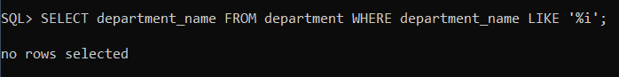

**QUESTION – 8**

Display the names of all the employees having supervisor with any of the following

SSN 554433221, 333445555.

**QUERY**

SELECT

    first_name,

    mid_name,

    last_name

FROM

    employee

WHERE

    supervisor_ssn IN ('554433221', '333445555');

**RESULT**

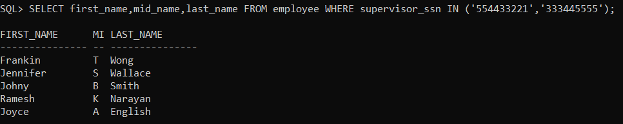

**QUESTION – 9**

Display all the department names in upper case and lower case.

**QUERY**

*-- UPPER*

SELECT

    UPPER(department_name)

FROM

    department;

*-- lower*

SELECT

    LOWER(department_name)

FROM

    department;

**RESULT**

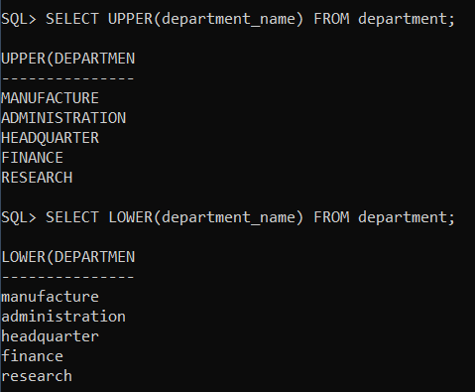

**QUESTION – 10**

Display the first four characters of the department names using substring function.

**QUERY**

SELECT

    SUBSTR(department_name, 1, 4)

FROM

    department;

**RESULT**

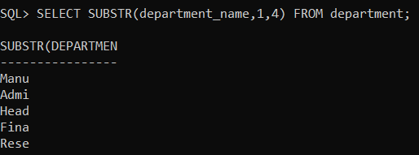

**QUESTION – 11**

Display the substring of the address (starting from 5th position to 11 th position) of

all employees.**QUERY**

SELECT

    SUBSTR(address, 5, 11)

FROM

    employee;

**RESULT**

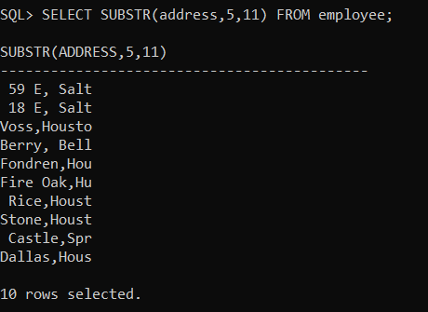

**QUESTION – 12**

Display the Mgrstartdate on adding two months to it.

**QUERY**

SELECT

    ADD_MONTHS(manage_start_date, 2)

FROM

    DEPARTMENT;

**RESULT**

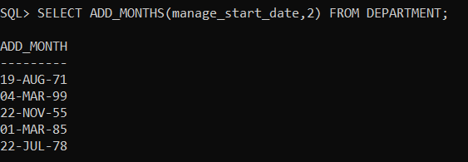

**QUESTION – 13**

Display the age of all the employees rounded to two digits.

**QUERY**

SELECT

    ROUND(MONTHS_BETWEEN(SYSDATE, birthday) / 12, 2)

FROM

    employee;

**RESULT**

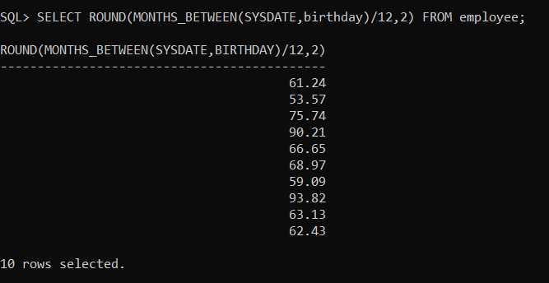

**QUESTION – 14**

Find the last day and next day of the month in which each manager has joined.

**QUERY**

SELECT

    LAST_DAY(manage_start_date),

    NEXT_DAY(manage_start_date, 'MONDAY')

FROM

    department;

**RESULT**

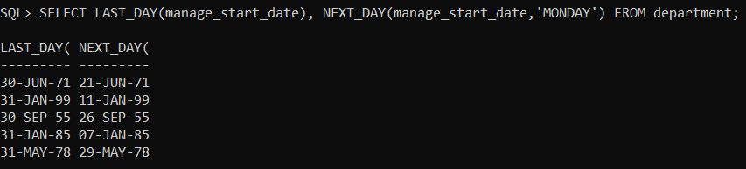

**QUESTION – 15**

Replace the string ‘na’ from ‘Ramana’ by ‘sri’.

**QUERY**

SELECT

    REPLACE('Ramana', 'na', 'sri')

FROM

    dual;

**RESULT**

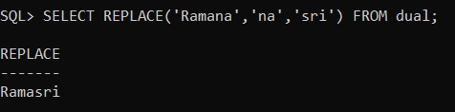

**QUESTION – 16**

Print the length of all the department names.**QUERY**

SELECT

    LENGTH(department_name)

FROM

    DEPARTMENT;

**RESULT**

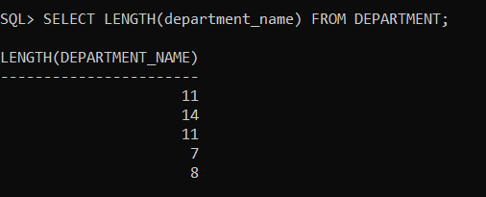

**QUESTION – 17**

Print the system date in the format 25 th May 2021.

**QUERY**

*-- CHANGING FORMAT*

ALTER session

set

    NLS_DATE_FORMAT = 'DDth Month YYYY';

*-- SYSTEM DATE*

SELECT

    SYSDATE

FROM

    DUAL;

**RESULT**

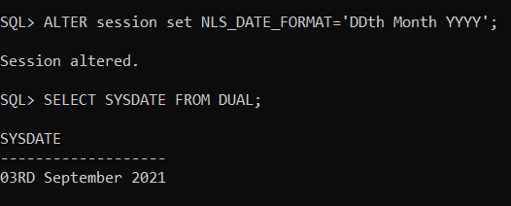

**QUESTION – 18**

Display the date after 8 months from current date.

**QUERY**

SELECT

    ADD_MONTHS(SYSDATE, 8)

FROM

    DUAL;

**RESULT**

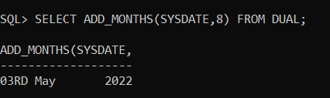

**QUESTION – 19**

Display the next occurrence of Friday in this month.**QUERY**

SELECT

    NEXT_DAY(SYSDATE, 'FRIDAY')

FROM

    DUAL;

**RESULT**

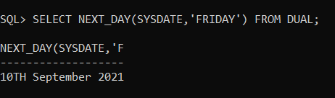

**QUESTION – 20**

Display the project location padded with **** on left side.

**QUERY**

SELECT

    LPAD(

        project_location,

        LENGTH(project_location) + 4,

        '*'

    )

FROM

    project;

**RESULT**

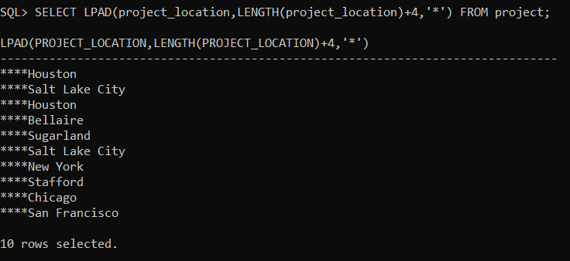

**GROUP FUNCTIONS**

**QUESTION – 1**

How many different departments are there in the ‘employee’ table?

**QUERY**

SELECT COUNT(DISTINCT department_number) FROM employee;

**RESULT**

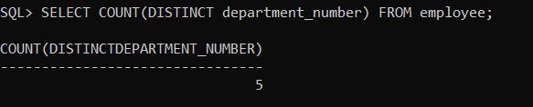

**QUESTION – 2**

For each department display the least and highest employee salaries along with

department number.

**QUERY**

SELECT MIN(salary), MAX(salary), department_number FROM employee GROUP BY department_number;

**RESULT**

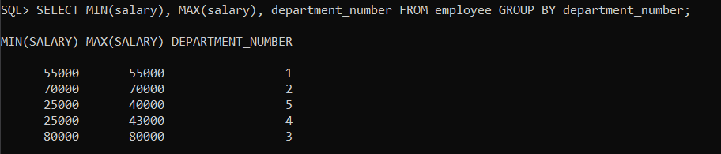

**QUESTION – 3**

Print the number of projects on which each employee is working on.**QUERY**

SELECT COUNT(DISTINCT project_number) FROM works_on;

**RESULT**

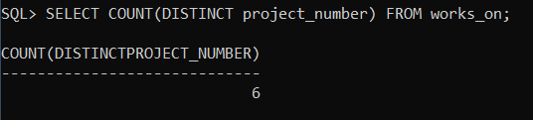

**QUESTION – 4**

Retrieve total number of hours spent on projects by each employee.

**QUERY**

SELECT project_number, SUM(hours) FROM works_on GROUP BY project_number;

**RESULT**

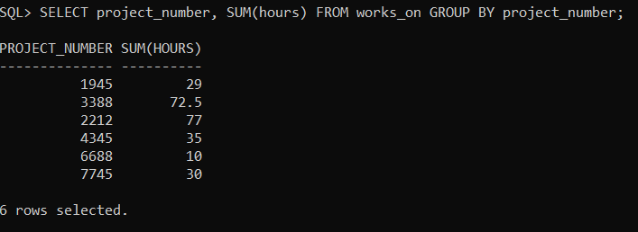

**QUESTION – 5**

Count the number of employees over 30 ages.

**QUERY**

SELECT count(ssn_number) FROM employee WHERE MONTHS_BETWEEN(SYSDATE,BIRTHDAY)/12>30;

**RESULT**

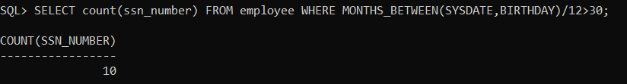

**QUESTION – 6**

Display the department number which contains more than 3 employees.**QUERY**

SELECT department_number FROM employee GROUP BY department_number HAVING COUNT(department_number) >=3;

**RESULT**

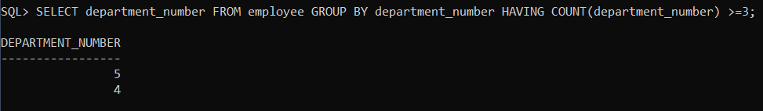

**QUESTION – 7**

Calculate the average salary of employees in each department.

**QUERY**

SELECT AVG(salary),department_number FROM employee GROUP BY department_number;

**RESULT**

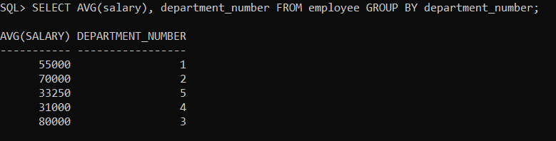

**QUESTION – 8**

Count the number of dependents for each employee.

**QUERY**

SELECT COUNT(dependent_name), employee FROM dependent GROUP BY employee;

**RESULT**

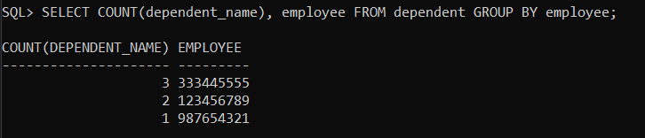

**QUESTION – 9**

Count the number of employees based on the seniority.

**QUERY**

SELECT count(ssn_number) FROM employee WHERE MONTHS_BETWEEN(SYSDATE,birthday)/12>60;

**RESULT**

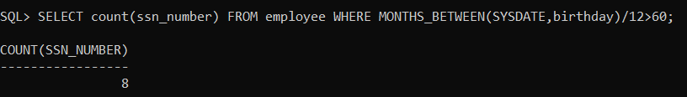

**QUESTION – 10**

Count the number of employees who works in ‘manufacture’ department.

**QUERY**

SELECT COUNT(department_number) FROM employee WHERE department_number IN(SELECT department_number FROM department WHERE department_name = 'Manufacture');

**RESULT**

